Asset ID | Image | Asset Name | Asset Type | Description / Intended Use | File Format | Source | Licence / Permissions | Notes
1 | 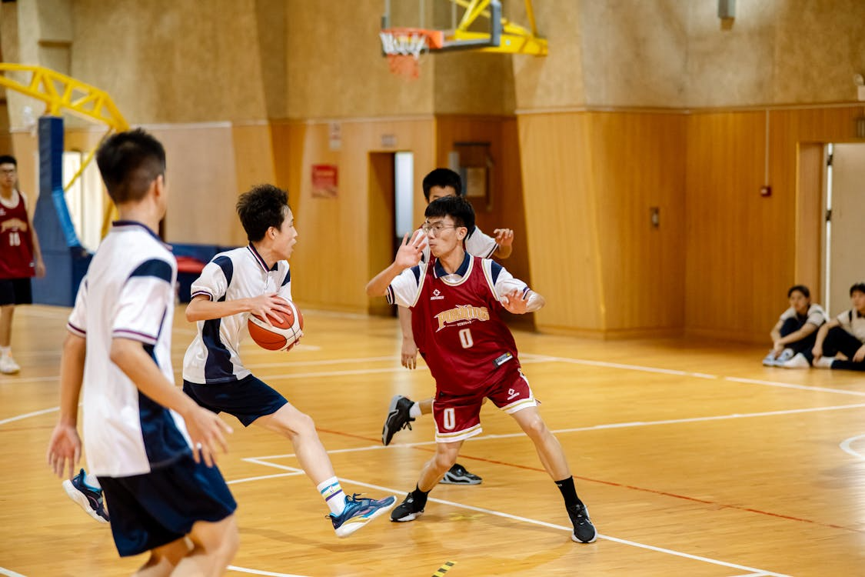 | Homepage Hero Image | Image | Group of young people playing basketball together, welcoming site intro | JPG | https://www.pexels.com/photo/intense-basketball-game-in-indoor-court-34197285/ | Free for commercial use | Cropped to remove additional skaters
2 |  | Search Icon | Icon |  | PNG | https://icons8.com/icon/e4NkZ7kWAD7f/search | Free
3 |  | Football Icon | Icon |  | PNG | https://img.icons8.com/?size=100&id=9820&format=png&color=000000 | Free
4 |  | Basketball Icon | Icon |  | PNG | https://img.icons8.com/?size=100&id=ubcMtSSdyRHI&format=png&color=000000 | Free
5 |  | Boxing  Icon | Icon |  | PNG | https://icons8.com/icon/YLMvAQ7fsst5/boxing-glove | Free
6 |  | Cricket  Icon | Icon |  | PNG | https://icons8.com/icon/CgP67foVm17G/cricket-game | Free
7 |  | Music  Club | Icon |  | PNG | https://img.icons8.com/?size=100&id=113920&format=png&color=000000 | Free
8 |  | Film & Media Club | Icon |  | PNG | https://img.icons8.com/?size=100&id=6Ujtt7adsfSb&format=png&color=000000 | Free
9 |  | Robotics Club | Icon |  | PNG | https://img.icons8.com/?size=100&id=3kQlqAGjT2rK&format=png&color=000000 | Free
10 |  | Drama Club | Icon |  | PNG | https://icons8.com/icon/12076/drama | Free
11 |  | Photography Club | Icon |  | PNG | https://img.icons8.com/?size=100&id=13077&format=png&color=000000 | Free
12 |  | Person Logo | Icon |  | PNG | https://www.freeiconspng.com/img/1682 | Free
13 | 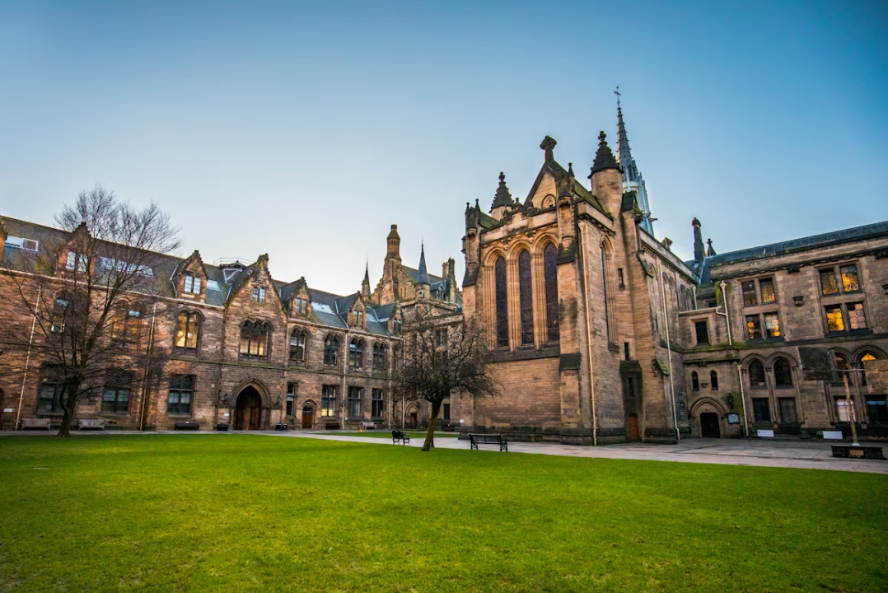 | University Background | Image |  | JPG | Brown concrete building photo – Free Universities Image on Unsplash  Static/Images/University.jpg | Free
14 |  | Arrow down | Icon |  |  | File:down Arrow Icon Wikipedia, The Free Encyclopedia PNG Transparent Background, Free Download #1158 - FreeIconsPNG | Free
15

